Consider the Internet protocol stack in Figures 1.23 and 4.31. Would you consider the ICMP protocol to be a network-layer protocol or a transport layer protocol? Justify your answer.

Figures 1.23 and 4.31

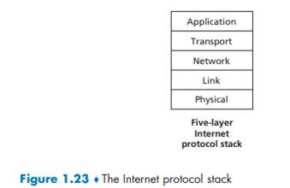



Step 1:

When network issues prohibit the transmission of IP packets, network devices like routers employ ICMP (Internet Control Message Protocol) to emit error messages to the source IP address. When a gateway to the internet, such as a router, service, or host, cannot be contacted for packet delivery, ICMP constructs and transmits messages to the originating IP address. Any device connected to an IP network is able to send, receive, or process ICMP packets.

Step 2:

A supporting protocol in the Internet protocol family is the Internet Control Message Protocol (ICMP). When talking with another IP address, network devices, including routers, utilise it to convey operational information and error messages indicating success or failure. For instance, an error is given when a requested service is not accessible or that a host or router could not be reached.  ICMP is different from transport protocols like TCP and UDP in that it is not frequently utilised by end-user network applications or to exchange data between systems (with the exception of some diagnostic tools like ping and traceroute).

Step 3:

As a result, ICMP is depicted as a layer 3 protocol in the subject on TCP/IP-based layered networks. The ping command uses the ICMP message protocol, which is probably its most well-known application. An ICMP echo request is sent to the target host by the ping command. The target host returns an echo reply in response.

It is without a doubt a network layer protocol. Because ICMP functions WITHOUT ANY transport layer, it is sometimes misunderstood with transport layer. Ping and traceroute, for instance, lack clearly specified ports. Instead, processing and responding to incoming ICMP messages is the responsibility of each machine's tcp/ip stack (rather than looking up a port and passing on to corresponding application, as is the case with all other applications).